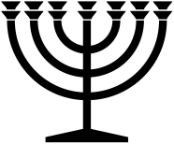 |  | December 2024
Sunday | Monday | Tuesday | Wednesday | Thursday | Friday | Saturday
1 | 2 | 3 | 4 | 5 | 6 | 7
 | S | NM
8 | 9 | 10 | 11 | 12 | 13 | 14
 |  | S
15 | 16 | 17 | 18 | 19 | 20 | 21
 |  | S
22 | 23 | 24 | 25 | 26 | 27 | 28
 |  | S |  |  | Hanukkah | Hanukkah
29 | 30 | 31
Hanukkah | Hanukkah | S  Hanukkah | Hanukkah | Hanukkah | January 3  Last Day of Hanukkah
RED = Sabbath BLUE = New Moon www.hope-of-israel.org

